|  |  |  |  |
| --- | --- | --- | --- |
| Artifact ID:  CD-004 | Artifact Title:  Reactive Tracking Concept Defintion | |  |
| Revision:  1.0 | Revision Date:  13 NOV 2019 | |
| Prepared by:  Autumn Twitchell | | Checked by:  Checker |
| Purpose:  The purpose of this artifact is to clearly communicate the concept for the reactive tracking system. | | |

# Revision History

|  |  |  |  |
| --- | --- | --- | --- |
| Revision: | Revised by: | Checked by: | Date: |
| 1.0 | Autumn Twitchell | Checker | 7 NOV 2019 |

# References

|  |  |  |
| --- | --- | --- |
| Artifact ID: | Revision: | Title: |
| CODE-001 | 1.0 | Code for Tracking Simulation |
| Decision tracking doc. | 1.0 |  |

# Definition

The tracking controls system refers to the coding method that we desire to use in order to properly track the in-flight vehicle. This does not include the computer hardware or the mechanical device we are using to track the vehicle. This concept involves the method of receiving data and determining what needs to happen with that data in order to find the in-flight vehicle. When the aircraft is in the antenna’s field of view and a communication link is established, we will receive the aircraft’s GPS coordinates. Using that information, we will update the gimbal with the location of the in-flight vehicle every half second so that it can keep the antenna on our system pointing within 8 degrees of the center of the plane at all times.

# Testing Observations

From our testing, we have found that this method of tracking works very well. We created a simulation in Python where we have an airplane flying at a speed of about 64 miles/hour in an oval shape that is simulated to be half a mile away. Generally, our in-flight vehicle will be greater than 2 miles away from our system, causing the airplane to appear to move slower in the sky. Therefore, if the tracking system works well in our simulation, it should also work well in real life. We have a field of view (FOV) square that is proportional to about 8 degrees in the sky from a point that is half a mile away. We update the FOV square every half second to reflect how we want it to perform in the actual world. When we run the simulation, it appears that updating the tracker every half second is plenty of time to make sure that the plane is always within the FOV. Therefore, it should be enough time to update the gimbal.

Below is really more for Decision Justification:

For information on how we came up with this decision in comparison to other considered concepts, see ARTIFACT.

**** maybe provide drawing of calculations

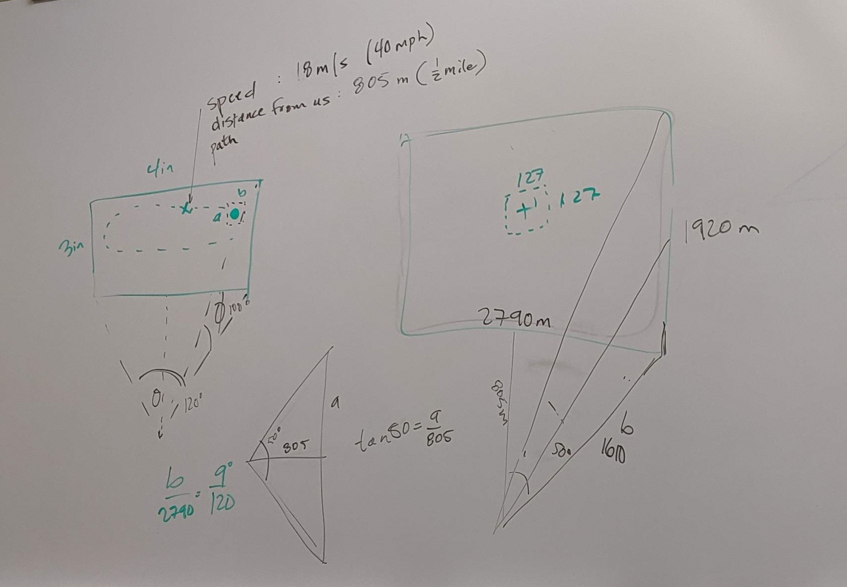

**Figure 1:** The image above shows the calculations that we performed in order to create an accurate simulation of what our in-flight vehicle will look like in the sky.

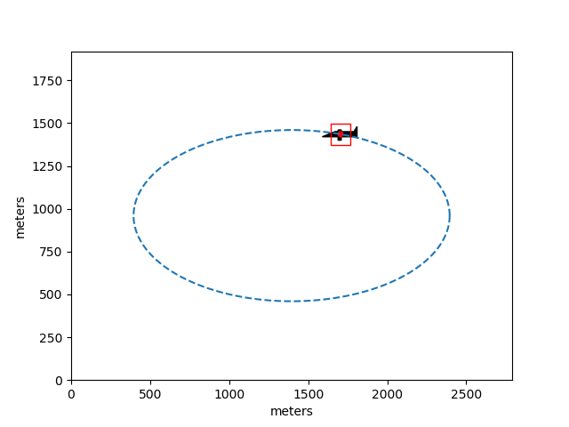

**Figure 2:** A plot of a simulation we ran to show that the tracker can keep the plane in the FOV at all times at an update rate of 2 Hz. The red box represents the calculated FOV, the red dot represents the center of the FOV, and the black airplane figure represents the airplane. See CODE-001 for more detail on how the simulation is run.